

PCA Regional Claim System

CI Server-Jenkins For Product Configuration

Date Prepared: 3 March 2016
Prepared By: Zheng Yanshan

Table of Contents

1. Introduction 4
1.1. Purpose 4
1.2. Definitions & Acronyms 4
2. Environment Setup 4
2.1. JDK configuration 4
2.2. Ant configuration 5
2.3. Jenkins setup 6
3. Jenkins Configurations 7
3.1. System management 7
3.2. Create one Jenkins task 7
4. How to use Jenkins 10
4.1. build task 10
4.2. Watch the update log 11
4.3. watch the console 12

Related Documents
No. | Document Name | Description

Document Change Record
Document Version | Author(s) / Position | Change Reference | Date
1.0 | Zheng Yanshan | First Release | March 03 2016
1.1 | Luan Dongfeng |  | 03-May-2016

Purpose
- Introduction
This document introduces general guidelines for the CI Server for product configuration.

Definitions & Acronyms

Abbreviation | Full Text
CI Server | Continuous Integration Server
- Environment Setup

Require Tools
- JDK
- Ant
- Jekins.war

JDK configuration
- Open “Advanced system settings”->”Environment Variables Setting”, new a System variables “JAVA_HOME” (assume this variables haven’t been created before).
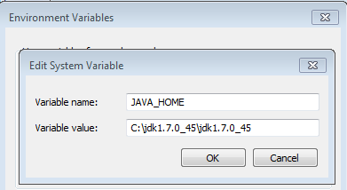

- Add the jdk path “%JAVA_HOME%\bin;” to System Vairable “Path”.
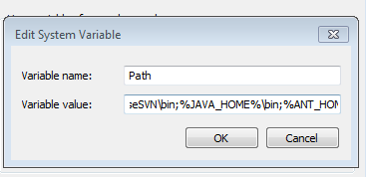

- New a System variables “CLASSPATH “(assume this variables haven’t been created before),value as “
.;%JAVA_HOME%\lib\dt.jar;%JAVA_HOME%\lib\tools.jar;”.

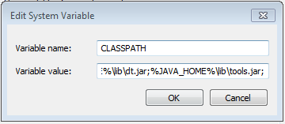

Ant configuration
- Assuming ant installation file have been downloaded and unzipped.
- Open “Advanced system settings”->”Environment Variables Setting”, new a System variables “ANT_HOME” (assume this variables haven’t been created before).
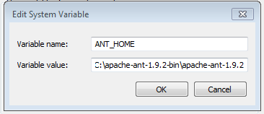

- Add the ant path %ANT_HOME%\bin;%ANT_HOME%\lib;” to System Vairable “Path”.
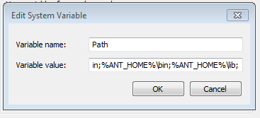

- Open “cmd console”, run “ant” in the location of ant file, to check if ant is configured.

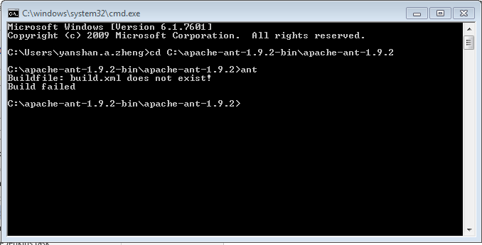

Jenkins setup
- Get jenkins.war from http://jenkins-ci.org/.
- Open “cmd console”, run “java –jar Jenkins.war” in the location of jenkins file, to set up Jenkins.
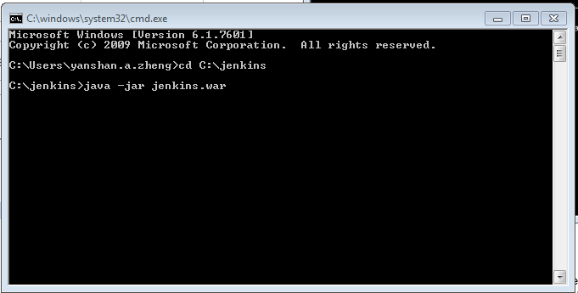

- After Jenkins have been set up, open the browser to visit the Jenkins website by key in the location: http://localhost:8080 ( 8080 is the default port for Jenkins server).
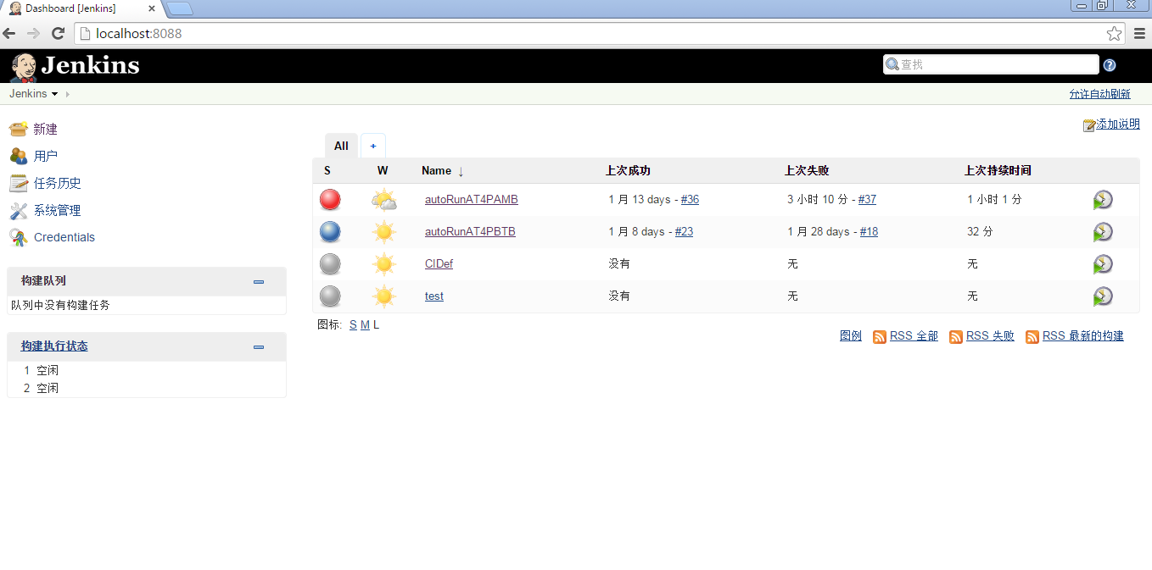
- Jenkins Configurations

System management

Click system management->install as windows services, in this page only JDK and ANT need to be config, others we can keep default value.
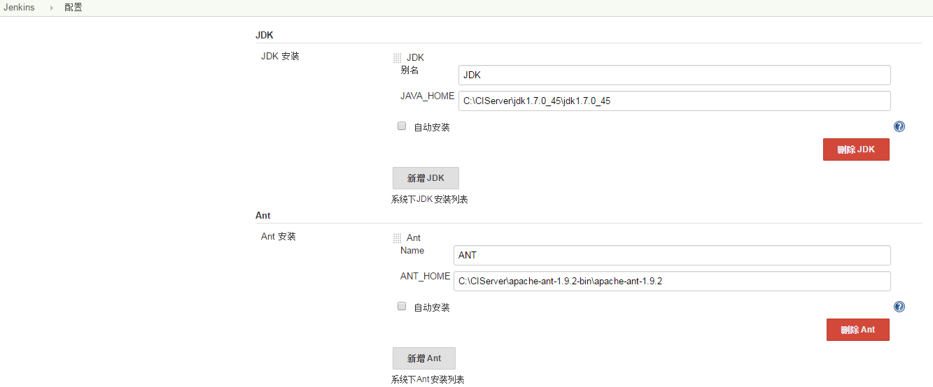

Create one Jenkins task
- open the browser to visit the Jenkins website by key in the location: http://localhost:8088;
- click “New” to create a Jenkins task.
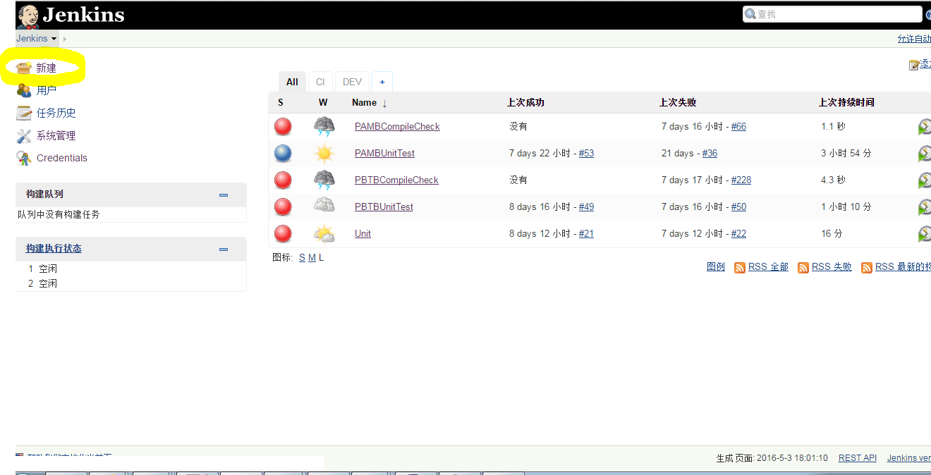

- To key in the item name, select the item type, then click “OK” to jump to the task configuration.
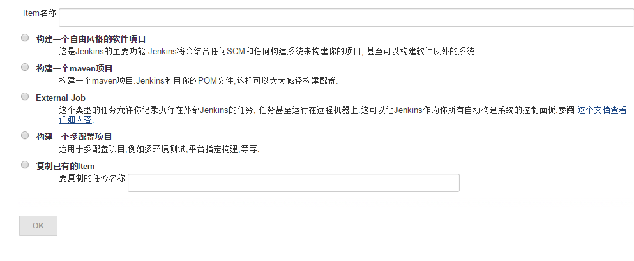
- To key in some description for the task.
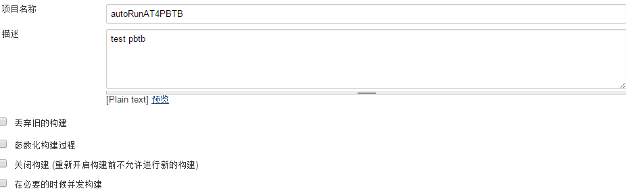
- In source management,select “Subversion”, and key in the detail information of Modules, assuming project use svn, and update the lastest source code is needed before building, if not, this step can be skipped.
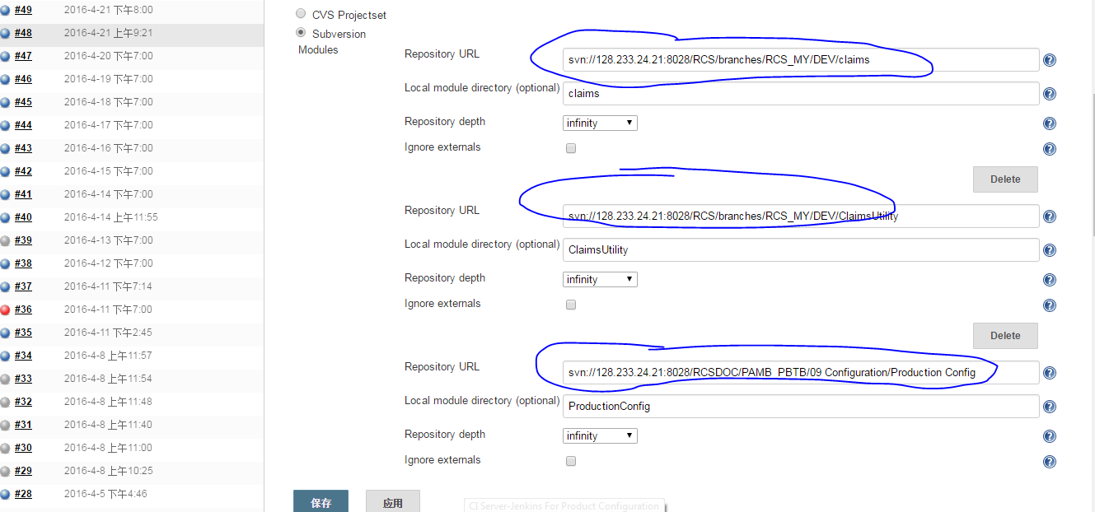

- Check-out strategy always use “svn update”.

- Select trigger for building and key in schedule,according to requirements.

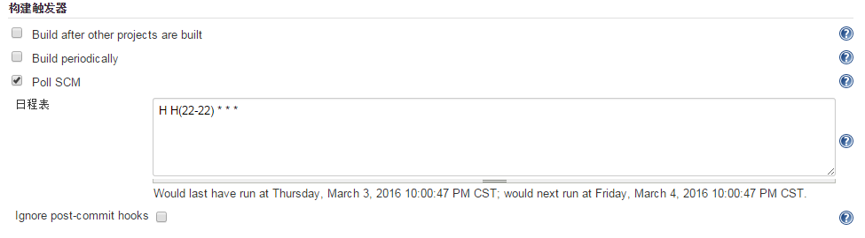
- At Build area, click “add building process”, select “Invoke Ant” then add the ant information refer to second picture.
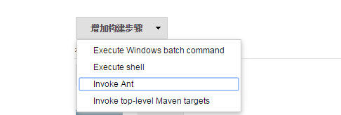s
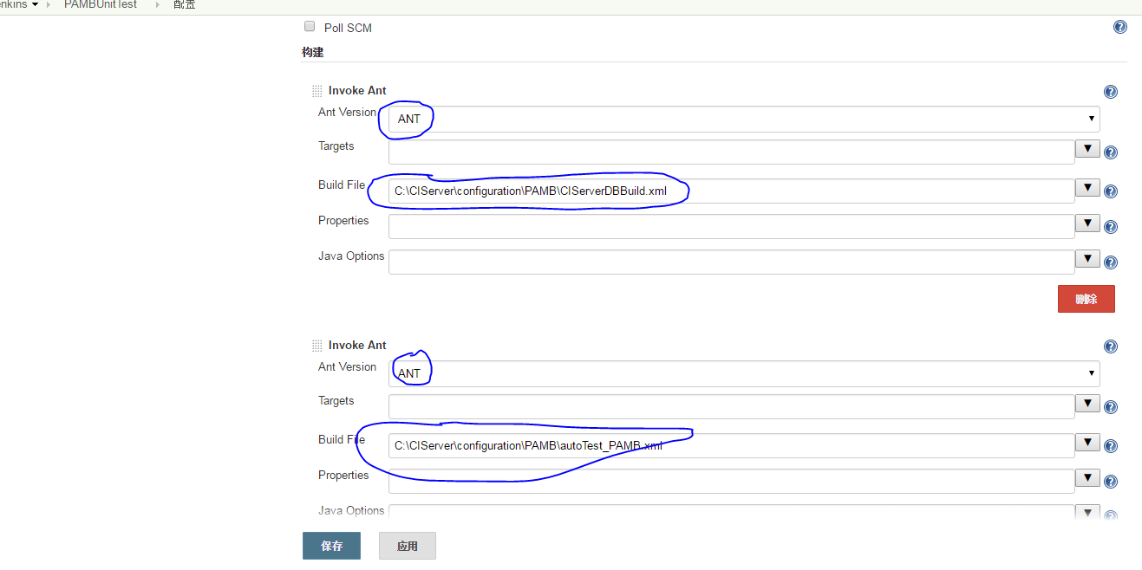
For CIServerDBBuild.xml and autoTest_PAMB.xml please as below:
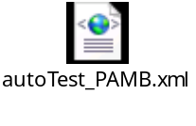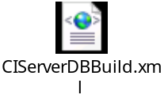

- Select “save” or “apply” to save a jenkins task.
- How to use Jenkins

build task
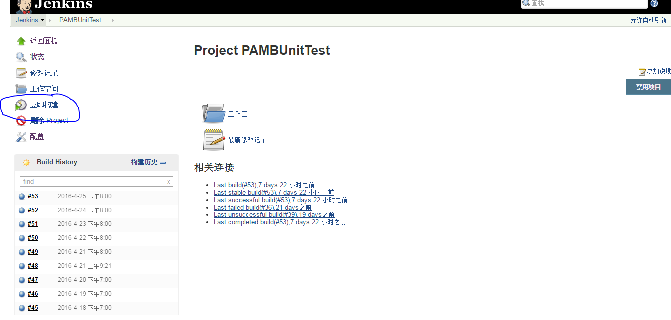

Watch the update log
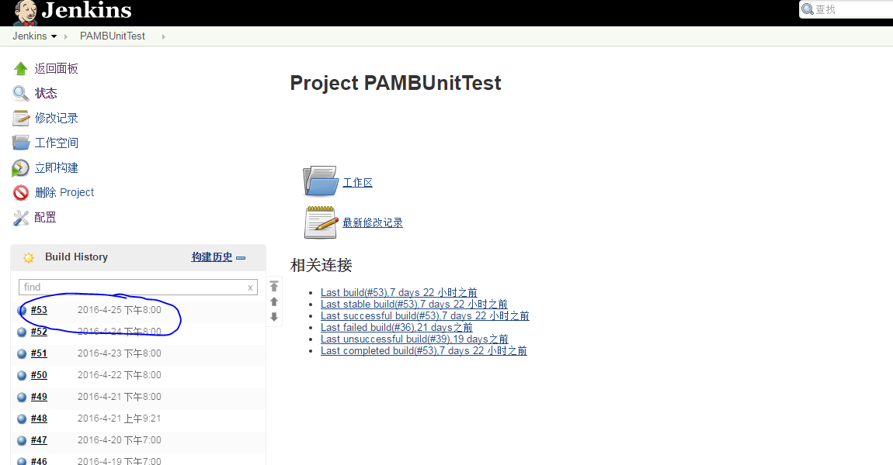
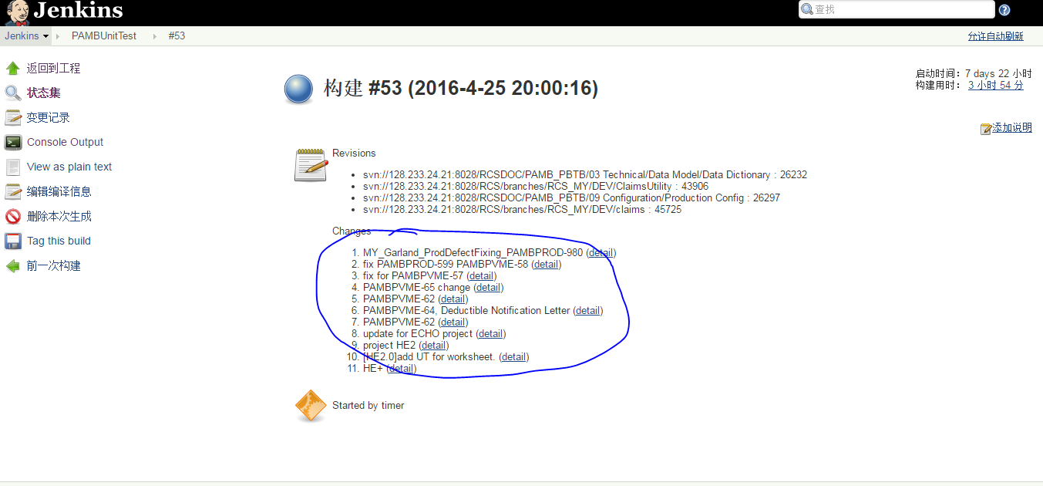

watch the console
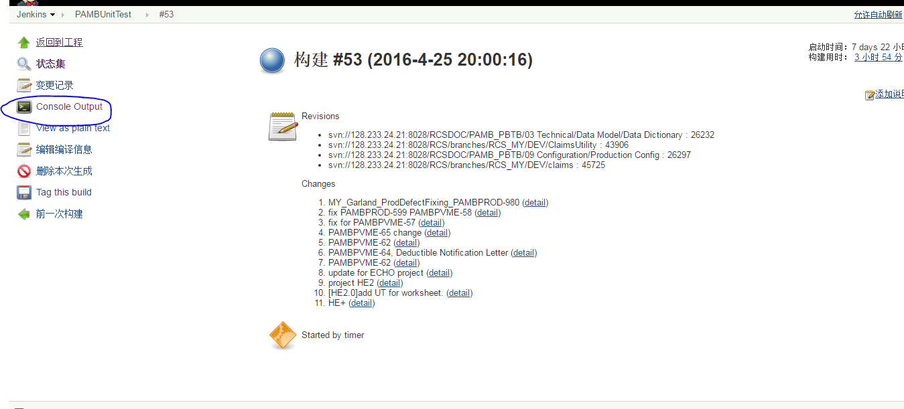
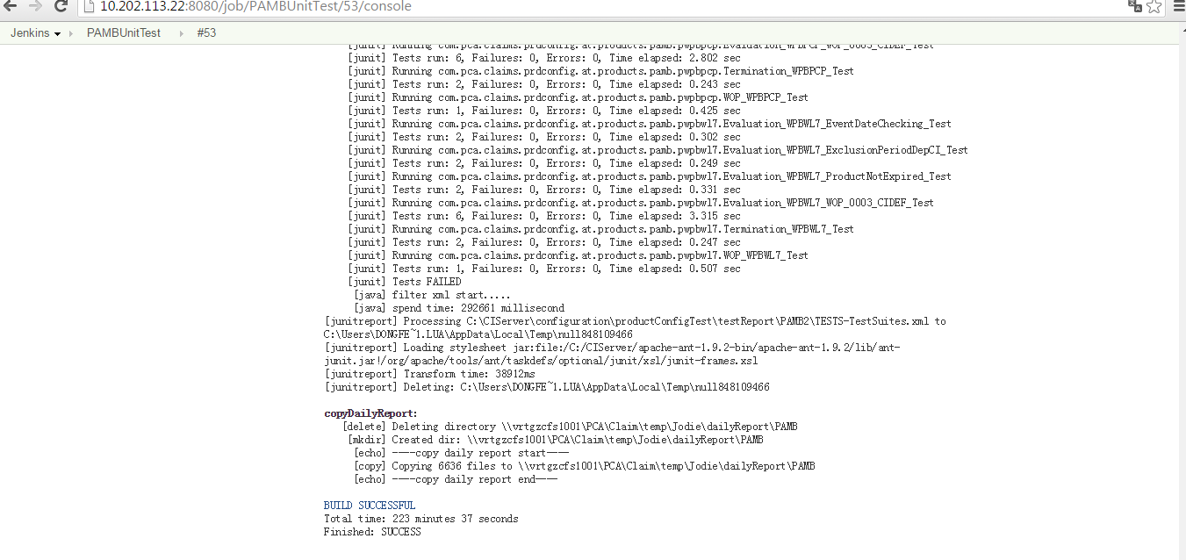

Daily report Control
The Jenkins task will be auto running everynight, for more configuration please refer to below
- Jenkins Server: http://10.202.113.22:8080
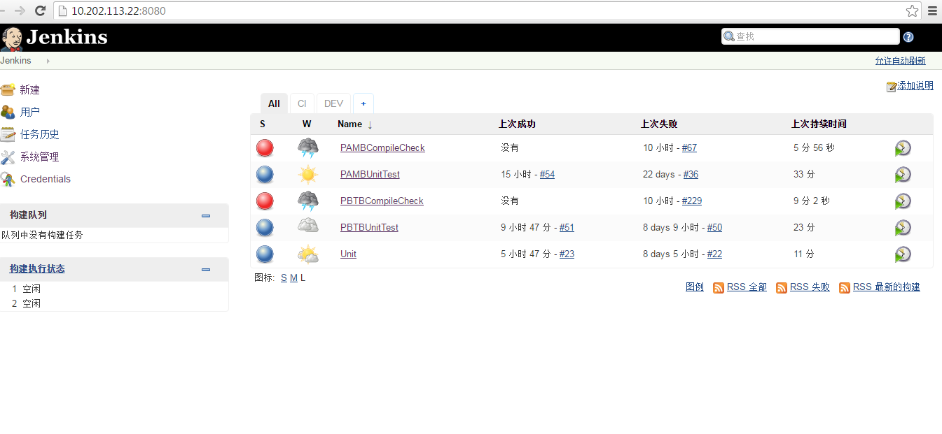
Task:
- PAMBCompileCheck: checking the PAMB source compile
- PAMBUnitTest: Junit report for PAMB product AT case
- PBTBCompileCheck: checking the PBTB source compile
- PBTBUnitTest: Junit report for PBTB product AT case

- Remote server configuration path
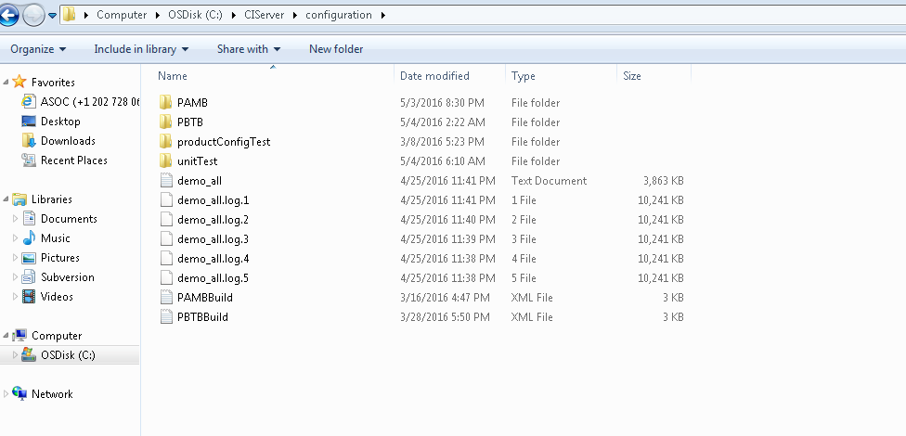
- PAMB folder: store the PAMB running script and basic configuration files.
- PBTB folder : store the PBTB running script and basic configuration files.
- productConfigTest folder: store the final report and it also will be copy to shareforder, PAMB and PBTB path refer to below
\\vrtgzcfs1001\PCA\Claim\temp\Jodie\dailyReport\PAMB
\\vrtgzcfs1001\PCA\Claim\temp\Jodie\dailyReport\PBTB
- PAMBBuild.xml: For config the PAMB source compile.
- PBTBBuild.xml: For config the PBTB source compile.

